How to Assign Chores

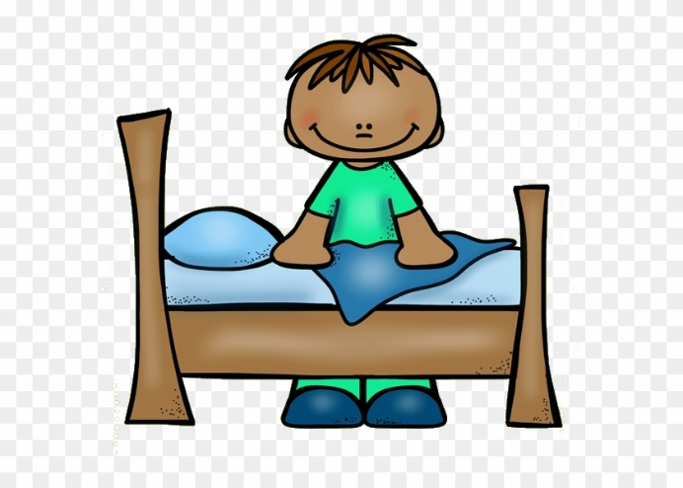Giving your child chores to do has a number of benefits, not only to your household but to their personal development. When kids do chores, they sense that they are contributing something important to the family.

Start off small. It's easy for a little one to get overwhelmed when faced with a playroom or bedroom with toys strewn all over the place. They often don't know where to start and consequently, end up giving up, throwing a [tantrum](https://www.verywellfamily.com/how-to-stop-temper-tantrums-2764638) or whining about it.

Instead of saying, "Clean up this room," give your child some specific directions — "Please put away all your cars." Once that task is finished, move on to something else. "Great job! Now it's time to pick up the crayons."

When coming up with a list of potential jobs for your little one, remember simple is key. Young children tend to have short attention spans so you need to find chores that are easy for them to complete where they won't get bored.

Give your child something above her ability and she's likely to feel disappointed and frustrated. But if she's able to do the job well, chances are she'll want to do more.

If at all possible, at least in the beginning or if the job is a big one like [cleaning up her room](https://www.verywellfamily.com/teach-your-preschooler-to-how-clean-up-toys-2764640), help your preschooler with her assigned task. As you clean up, talk about why what you are doing is necessary — "We need to feed the dog so she'll grow strong and be healthy."